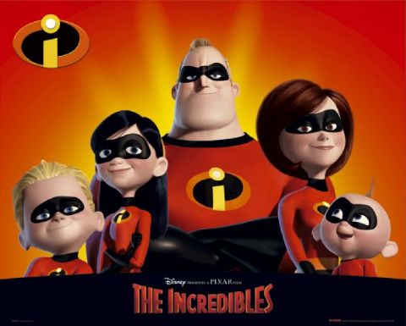
This Photo by Unknown Author is licensed under CC BY-SA
BE INCREDIBLE! Invitational 2018
Date: April 21 & 22, 2018
Location: Gymtastiks of Moose Jaw
Hillcrest Sports Centre
1599 Main Street N. Moose Jaw, SK.S6J 1L5

Entry Fee: $90.00 J.O. 3-7
$60.00 J.O. 1 & 2
$40.00 for Recreational

Payment can be made by one cheque, made payable to Gymtastiks of Moose Jaw. Please send a hard copy of your registration with all waivers and T Shirt Size for athletes & coaches. Each athlete registered by the deadline will receive a T Shirt. Late registrations will not be guaranteed a T Shirt. Please submit registrations via e-mail.
Registrations are due Wednesday, March 14, 2018. Registrations received after March 14th will be subject to a $25.00 late fee per athlete. Space is limited so register early. Spots will be awarded on a first come first serve basis until we are full.
Refunds for medical reasons will be given, with a doctor’s note, on or before April 17th, 2018. Gymnasts will be registered when both forms and payment have been received.

Judges: As per Gymnastics Saskatchewan Policy.
NOTE: Fines will be charged as per Gymnastics Saskatchewan policy for missing judges. Fines MUST be paid before start of competition.
Deadline: Deadline is March 14TH, 2018. Please do not send as PDF.

Awards: J.O. 1-7 As per Gymnastics Saskatchewan Policy.
Recreational – participation medal.

Inquiries: Barb Jesse
Phone: 306-692-2303
E-Mail: office@gymtastiks.com

Music: Compulsory music will be supplied

ACCESS TO THE GYM is from Main Street turning East onto Thatcher only!
HOTEL DEALS
Heritage Inn 1-888-888-4374
1 Special Breakfast room $103.50 + taxes
2 double beds – breakfast for up to 4 people

Comfort Inn 1-800-414-6423
$103.00 – reserved to March 20/18
Group Account: 3238284
2 queen size beds
Book 15 rooms – get coach room free

Ramada Inn - $125.00
1 (800) 854-9517
2 double beds – breakfast included

GYMTASTIKS OF MOOSE JAW
This Photo by Unknown Author is licensed under CC BY-SA
BE INCREDIBLE! INVITATIONAL
APRIL 21 & 22, 2018
TENTATIVE SCHEDULE
SATURDAY APRIL 21ST, 2018
SESSION 1 – 8:00-10:30 J.O. 3 2008-2009 & 2007
SESSION 2 – 10:30-1:00 J.O. 3 2004+ & 2005-2006
SESSION 3 –1:30-5:00 J.O. 4-7
SESSION 4 –5:00-8:00 J.O. 2
SUNDAY April 22ND, 2018
SESSION 5 – 8:00-11:00 J.O. 2
SESSION 6 – 11:00-2:30 J.O. 1
SESSION 7 –2:30-6:00 J.O. 1 & RECREATIONAL
**** J.O. 1 & 2 SESSIONS – PLACEMENT OF CLUBS WILL BE DETERMINED AFTER REGISTRATION DEADLINE.
We reserve the right to utilize one Session on Friday evening if needed.
WAIVER

Name of Athlete: _________________________________AGE: ______________
PLEASE PRINT CLEARLY

GYMTASTIKS OF MOOSE JAW
BE INCREDIBLE! Invitational
April 21 & 22, 2018

In consideration of your acceptance of my entry I, intending to be legally bound do hereby, for myself, my heirs, executors and administrators waive and release and forever discharge any and all rights and claims for damage which I may have or may hereafter accrue to me against the Gymnastics Saskatchewan Association, the organizers or their respective officers, agents, representatives and/or assigns for any and all damages which may be sustained and suffered by me in connection with my association with or entry in the above athletic meet or which may arise out of my traveling to or participating in and returning from said athletic meet.

Submission of your registration to the Gymtastiks BE INCREDIBLE! Invitational constitutes your consent to collect, use, disclose and retain your personal information as is reasonable for Gymnastics Saskatchewan and the Gymtastiks Club for the following purposes:
Name, event results, programs, web site results and photo posting.

Athlete’s Signature
(If 18 years of age or over)

Parent/Guardian Date

GYMTASTIKS OF MOOSE JAW
BE INCREDIBLE! Invitational
April 21 & 22, 2018
RECREATIONAL ROUTINE SHEET

Please list skills that will be performed; fill out a sheet for each athlete attending.
Please ensure skills are at the athlete’s level.

ATHLETE NAME: ____________________________________________

VAULT – CHOOSE FROM (Please indicate which one):
- Squat on to 60 cm Box
- Handstand fall to back on crash mat
- Handspring to back on 110 cm mats, with Mini Tramp

BARS – 6 skills
__________________________________________________________________________________________________________________________________________________________________________________________________________________________________________________________________________________________________________________________________________________________________________________________________________________________________________________________________________________________________________

BEAM – 6 skills (mount, 1 turn, 2 leaps or jumps, 1 scale or acro, dismount)
__________________________________________________________________________________________________________________________________________________________________________________________________________________________________________________________________________________________________________________________________________________________________________________________________________________________________________________________________________________________________________

Floor – 6 skills (3 acro skills, 1 turn, 2 leaps or jumps)

