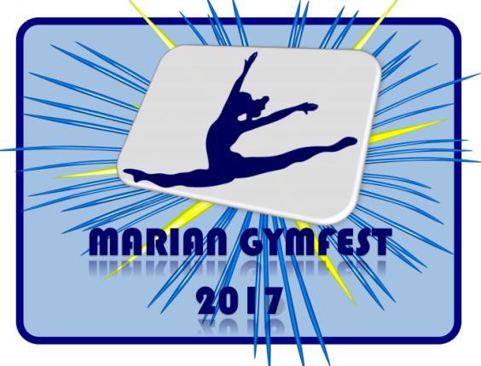

Presents the Marian Gymfest 2017

Date: Sunday, December 3, 2017

Location: Marian Gymnastics Club
343 Edson Street
Saskatoon, SK

Entry Fee: $60.00 JO Level 1 & 2, FastCat
$45.00 Recreational Division
$35.00 Developmental Testing (Marian gymnasts only)

Please make one cheque payable to Marian Gymnastics Club. Registrations are due Thursday, November 9, 2017.

Registrations received after November 9th, 2017 will be subject to a $25.00 late fee. Athletes will be registered when both forms and payment have been received. Refunds for medical reasons will be given with a doctor’s note on or before November 30, 2017.
Tentative LEVEL SESSION TIME
Schedule: JO 1 Sunday Morning 8:30-11:30am
JO 2 Sunday Afternoon 11:30am-3:00pm
Rec Division Sunday Afternoon 3:00-5:00pm
FastCat Sunday Afternoon 3:00-5:30pm
Dev Testing 1-6 Sunday Evening 4:00-6:00pm
**Please note, the meet schedule is subject to change. The confirmed schedule will be emailed to participating clubs, as well as available on gymsask.com and mariangym.com.

Judges: As per the Gymnastics Saskatchewan Policy

All clubs are required to bring one qualified judge for every six gymnasts competing in JO Level 1 and JO Level 2.

Fast Cat judges as per Gymnastics Saskatchewan Technical regulations.

Schedule/Session groupings will be sent to the clubs.

Rules: As per GymSask Technical Regulations and Canadian JO Manual.

Deadline: Deadline for registration form and cheque is November 9th, 2017

Awards: JO Levels 1 & 2 and Fast Cat as per Gym Sask Regulations.

Equipment: All Spieth Anderson.

Nearby Four Points by Sheraton (306-933-9889)
Hotels: 103 Stonebridge Blvd, Saskatoon SK, S7T 0G3

Hampton Inn Saskatoon South (306-665-9898)
105 Stonebridge Blvd, Saskatoon SK, S7T 0G3)

Home Inn & Suites Saskatoon South (306-657-4663)
253 Willis Cres, Saskatoon, SK

Inquiries: marian.comp@gmail.com

Mailing MARIAN GYMNASTICS CLUB
Address: 343 EDSON STREET
SASKTOON, SK S7J 4C8

** Please note admission and concession will be cash only.

ATHLETE WAIVER FORM 2017

Name of Athlete:

Club:

Name of Event: Marian Gym Fest 2017

Date of Event: Sunday December 3rd, 2017

In consideration of your acceptance of my entry, I intend to be legally bound, do hereby for myself, my heirs, executors and administrators, waive and release and forever discharge any and all rights and claims for damage which may have or may hereafter accrue to me against the Marian Gymnastics Club, the organizers or their respective officers, agents, and/or assigns for any and all damages which may be sustained and suffered by me in connection with my association with or entry in the above athletic meet or which may arise out of my traveling to, or participating in, and returning from, said meet.

Athlete Signature Signature of Parent or Guardian
(If 18 years of age or older) (If under 18 years of age)

Date

