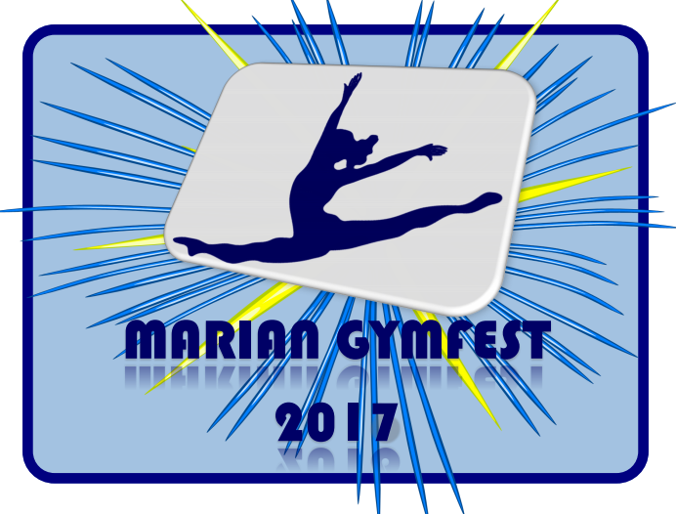
Gymnast Skills list

Gymnast Name:__________________________________________________________________

Vault: Circle one of the following:

Squat on to 60 cm Box Handstand fall to back on mat Handspring to back
on 110 cm mats with
with tramp board
Bars: 6 skills, please list:

1) | 2)
3) | 4)
5) | 6)

Beam: 6 skills, please list:

Mount
Turn
Jump 1
Jump 2
Acro or Scale
Dismount

Floor: 6 skills, please list:

Acro 1
Acro 2
Acro 3
Turn
Leap/Jump 1
Leap/Jump 2

Recreational Meet Info Package

Location: Marian Gymnastics Club
343 Edson Street
Saskatoon, SK

Entry Fee: $45.00
Please make one cheque payable to Marian Gymnastics Club. Registrations are due Thursday November 9th, 2017.

Registrations received after November 9th, 2017 will be subject to a $20.00 late fee. Athletes will be registered when both forms and payment have been received. Refunds for medical reasons will be given with a doctor’s note on or before November 19th, 2017.

Routines: Athletes will be judged on skills listed on the routine sheet.
Please note that spotting will be allowed. There will be a low
& a medium beam. Music is allowed for floor (45sec or less please).

Awards: Gymnasts will receive a participation ribbon and a gift.

