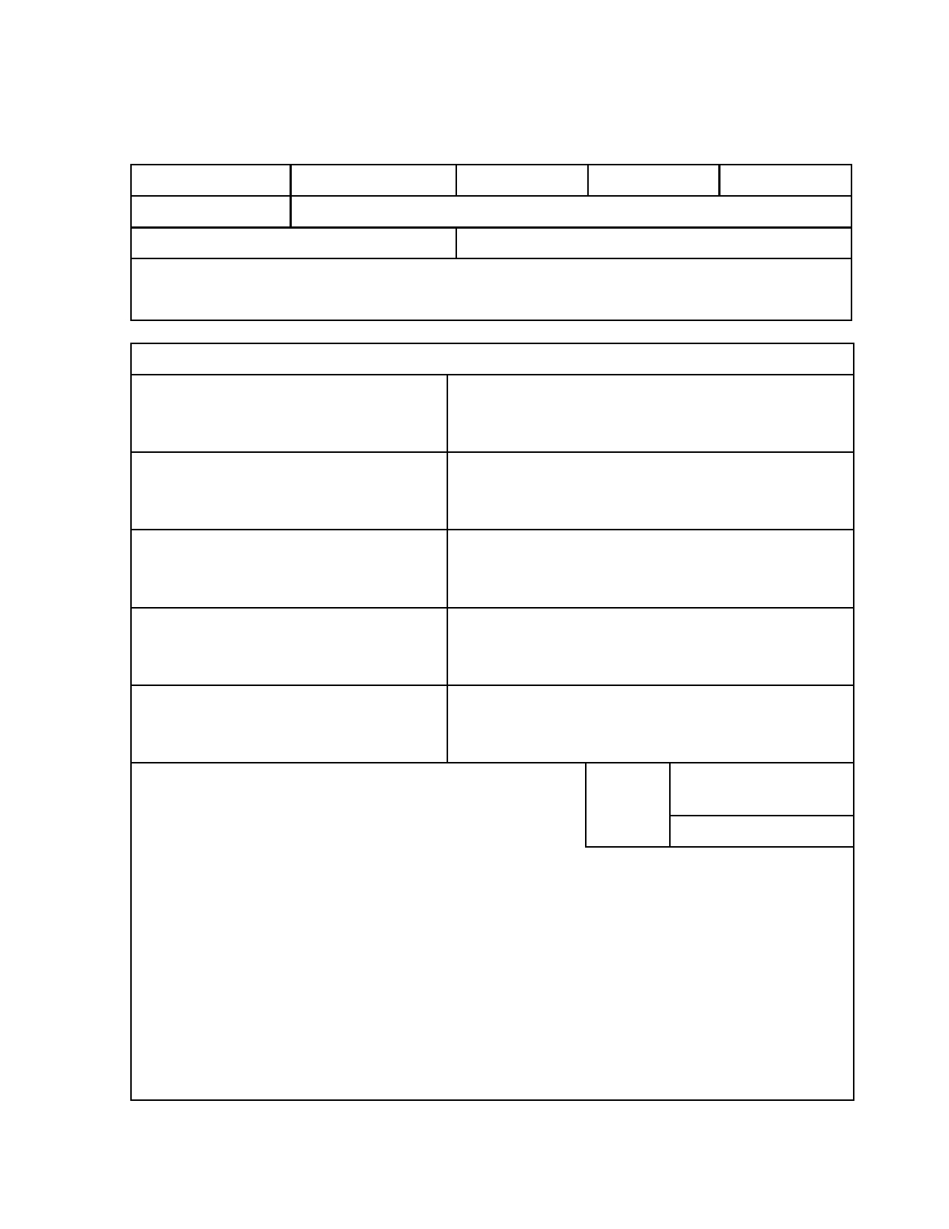
Challenge Cup 2019
ARTISTRY

Age Category: Under 12 12-14 15-17 18+ Masters
Group Name:
APPARATUS FREE
Costume Notes:

Artistic Elements

Team Unity
synchronization & unison

Composition
distribution and balance of elements

Music & Theme
suitable to gymnasts age & maturity

Originality
Innovative choreography

Overall Impression

0

0

0

0

0

1

1

1

1

1

2

2

2

2

2

3

3

3

3

3

4

4

4

4

4

5

5

5

5

5

COMMENTS:
TOTAL
SCORE: 25

Adjudicator: ____________________________

