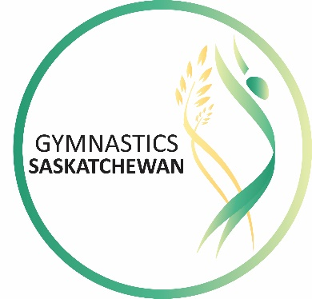

CELEBRATE GYMNASTICS AWARDS 2018
GYMNASTICS SASKATCHEWAN
AWARDS AND RECOGNITION PROGRAM

June 4, 2018

The Gymnastics Saskatchewan Celebrate Gymnastics Awards honor volunteers, staff, coaches, officials, athletes, clubs and sponsors for their contributions and achievements in gymnastics in the province. All members are encouraged to participate in the nomination process. Deadline for nominations is September 1st. Awards will be presented only if and when there are deserving candidates.

Awards will be presented at the annual Celebrate Gymnastics Awards Gala, to be held Saturday, November 3rd, 2018 at the Delta Hotel in Regina. Three finalists will be selected by our Technical Committees for each of the Athlete of the Year Awards will be invited, with the winner being announced at the Gala. For all other awards, winners will be notified in September.

LIFETIME ACHIEVEMENT AWARD
The Lifetime Achievement Award recognizes former or current Gymnastics Saskatchewan members whose long-term service, significant contribution and/or legacy have had a lasting impact on gymnastics in Saskatchewan. Builders, coaches, officials, athletes, staff or volunteers are eligible.

LEADERSHIP AWARD
The Leadership Award is presented to a coach, judge, program director or administrator who has contributed significant time and energy to the success of a club, a provincial team program, the development of an athlete, and has made an impact on the sport at the local, provincial and/or national level.

VOLUNTEER OF THE YEAR
The Volunteer of the Year is presented to a club or Gymnastics Saskatchewan volunteer who, through their volunteer leadership activities, has contributed significant time and energy to the success of a club, provincial and/or national program.

AWARDS OF MERIT
Awards of Merit are presented in honor of extraordinary service, accomplishment, or support, by an individual, group, team, club, organization, or corporate partner. The award shall not duplicate any award currently available but it could act as a vehicle for special contributions that would otherwise not be recognized.

ATHLETES OF THE YEAR (NATIONAL AND PROVINCIAL STREAM)
The top three competitive athletes in each category will be ranked by the Technical Committees based on performance results/points from the competitive season. Winners will be selected by the Gymnastics Saskatchewan Awards Committee, and announced at the Celebrate Gymnastics Awards Gala.

Eligibility for selection:
- All recipients must show outstanding qualities as a leader, a good sportsperson, and must abide by the guidelines of fair play and teamwork.
- Athletes must have competed at the Provincial Stream and/or National Stream level for a minimum of three years prior to selection.
- Athletes who have been finalists for a National Stream award in the past three years are ineligible for consideration for a Provincial Stream award.

- WAG Provincial Athletes of the Year
- WAG National Athlete of the Year
- MAG Provincial Athletes of the Year
- MAG National Athlete of the Year
- TG Provincial Athlete of the Year
- TG National Athlete of the Year
- RG Provincial Athlete of the Year
- RG National Athlete of the Year

GYMNASTICS SASKATCHEWAN – 2018 CELEBRATE GYMNASTICS AWARDS

NOMINEE INFORMATION:

Nominee’s Name:

Category Nominated For:

Nominee’s Home Address:

Nominee’s Email Address:

Nominee’s Club/Position:

ACHIEVEMENTS:

Please submit a biography including the accomplishments and achievements of this individual, and why they deserve this award.

Nominated By:

Address:

Email Address:

Phone:

Club/Position:

Please return to Gym Sask at kmiller@gymsask.com or fax to 306-780-9475
Deadline for nominations is September 1, 2018

