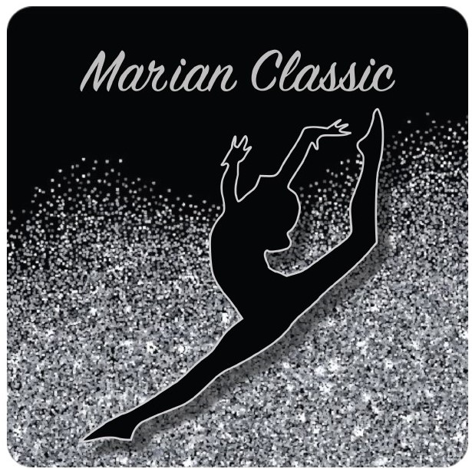

Date: February 8 – 10, 2019

Location: Marian Gymnastics Club
343 Edson Street & 337 Edson Street
Saskatoon

Entry Fee: $70 JO Levels 1 & 2
$105 JO Levels 3 – 10, Aspire

Please make one cheque payable to Marian Gymnastics Club.
E transfer is also acceptable – please enquire via email to: marian.comp@gmail.com
Registrations are due on January 15th, 2019.

Registrations received after January 15th, 2019 will be subject to a $40
late fee. Athletes will be registered when forms and payment have
been received. Refunds for medical reasons will be provided with
receipt of a Physician’s note on or before January 25th 2019.

Tentative
Schedule: The meet schedule will be released following receipt of entries on
January 18th. Schedule will be emailed and available on our Website

Judges: As per Gym Sask policy:
Please see the Gym Sask policy for information

Rules: As per Gym Sask Technical Regulations and Canadian JO Manual

Deadline: Registration form, Waivers and Cheque by January 15th, 2019

Awards: All Around 1st Trophy, 2nd and 3rd Medals, 4th – 8th ribbons
Events 1st – 3rd medals, 4th – 8th ribbons

Equipment: All Speith Anderson. Clubs may bring other boards.

Hotels: There are four brand new hotels near the gym. We invited you
to check

Four Points By Sheraton (306) 922 – 9889

Hampton Inn South (306) 665-9898

Home Inn & Suits (306) 657-4663

Marriott Town Place Suites (306) 952 - 0400

Mailing
Address: Marian Gymnastics Club
343 Edson Street
Saskatoon, SK
S7J 4C8

ATHLETE WAIVER FORM 2019

Name of Athlete:

Club:

Name of Event: Marian Classic Invitational 2019

Date of Event: February 8th, 9th, and 10th 2019

In consideration of your acceptance of my entry, I intend to be legally bound, do hereby for myself, my heirs, executors and administrators, waive and release and forever discharge any and all rights and claims for damage which may have or may hereafter accrue to me against the Marian Gymnastics Club, the organizers or their respective officers, agents, and/or assigns for any and all damages which may be sustained and suffered by me in connection with my association with or entry in the above athletic meet or which may arise out of my traveling to, or participating in, and returning from, said meet.

Athlete Signature Signature of Parent or Guardian
(If 18 years of age or older) (If under 18 years of age)

Date

