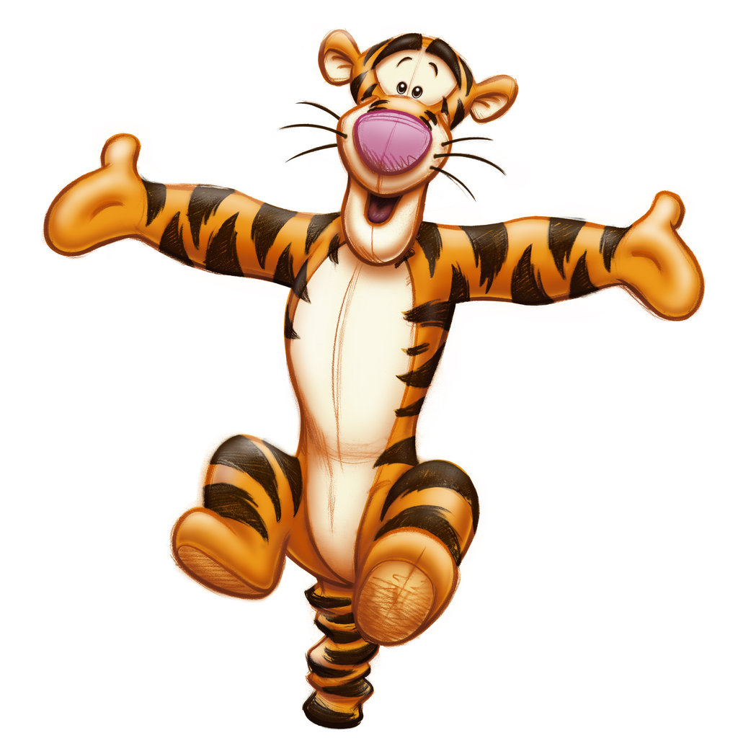

SPRING INTO SPRING Invitational 2019
Date: March 22-24, 2019
Location: Gymtastiks of Moose Jaw
Hillcrest Sports Centre
1599 Main Street N. Moose Jaw, SK.S6J 1L5

Entry Fee: $105.00 J.O. 3-7
$70.00 J.O. 1 & 2
$40.00 for Recreational

Payment can be made by one cheque, made payable to Gymtastiks of Moose Jaw. Please send a hard copy of your registration with all waivers. Each athlete registered by the deadline will receive a T Shirt. Late registrations will not be guaranteed a T Shirt. Please submit registrations via e-mail complete with T shirt sizes for athletes and coaches. Please submit Recreational Routines as soon as possible.
Registrations are due Wednesday, February 13, 2019. Registrations received after February 13th will be subject to a $25.00 late fee per athlete. Space is limited so register early. Spots will be awarded on a first come first serve basis until we are full.
Refunds for medical reasons will be given, with a doctor’s note, on or before March 16, 2019. Gymnasts will be registered when both forms and payment have been received.

Judges: As per Gymnastics Saskatchewan Policy.
NOTE: Fines will be charged as per Gymnastics Saskatchewan policy for missing judges. Fines MUST be paid before start of competition.
Deadline: Deadline is February 13th, 2019. Please do not send as PDF.

Awards: J.O. 1-7 As per Gymnastics Saskatchewan Policy.
Recreational – participation medal.

Inquiries: Barb Jesse
Phone: 306-692-2303
E-Mail: office@gymtastiks.com

Music: Compulsory music will be supplied

ACCESS TO THE GYM is from Main Street turning East onto Thatcher only!
HOTEL DEALS – make sure to mention that you are a participant at the Moose Jaw Gymtastiks Competition.
Comfort Inn
-Located at 155 Thatcher Dr W
-$99 plus taxes for a standard room
-Call 306.692.2100 to book

Heritage Inn Hotel & Convention Centre
-Located at 1590 Main St N
-$106 plus applicable fees & taxes, based on 2 adults. Kids under 16 free.
-Call 306.693.7550 to book

Suburban Extended Stay
-Located at 323 Diefenbaker Dr
-$119 plus taxes
-Call 306.972.7829 to book

The following hotels will have regular season rates available:

Grant Hall Hotel
-Located at 401 Main St N
-Call 1.844.885.4255 to book

Temple Gardens Hotel & Spa
-Located at 24 Fairford St E
-Call 1.800.718.7727 to book

Super 8 by Wyndham
-Located at 1706 Main St N
-Call 306.692.8888 to book

GYMTASTIKS OF MOOSE JAW
SPRING INTO SPRING INVITATIONAL
MARCH 22 – 24, 2019
TENTATIVE SCHEDULE
SATURDAY MARCH 23, 2019
SESSION 1 – 8:00-10:30 J.O. 3 2008-2009 & 2007
SESSION 2 – 10:30-1:00 J.O. 3 2004+ & 2005-2006
SESSION 3 –1:30-5:00 J.O. 4-7
SESSION 4 –5:00-8:00 J.O. 2
SUNDAY MARCH 24, 2019
SESSION 5 – 8:00-11:00 J.O. 2
SESSION 6 – 11:00-2:30 J.O. 1
SESSION 7 –2:30-6:00 J.O. 1 & RECREATIONAL
**** J.O. 1 & 2 SESSIONS – PLACEMENT OF CLUBS WILL BE DETERMINED AFTER REGISTRATION DEADLINE.
We reserve the right to utilize one Session on Friday evening if needed.

WAIVER

Name of Athlete: _________________________________AGE: ______________
PLEASE PRINT CLEARLY

GYMTASTIKS OF MOOSE JAW
SPRING INTO SPRING Invitational
MARCH 22-24, 2019

In consideration of your acceptance of my entry I, intending to be legally bound do hereby, for myself, my heirs, executors and administrators waive and release and forever discharge any and all rights and claims for damage which I may have or may hereafter accrue to me against the Gymnastics Saskatchewan Association, the organizers or their respective officers, agents, representatives and/or assigns for any and all damages which may be sustained and suffered by me in connection with my association with or entry in the above athletic meet or which may arise out of my traveling to or participating in and returning from said athletic meet.

Submission of your registration to the Gymtastiks SPRING INTO SPRING Invitational constitutes your consent to collect, use, disclose and retain your personal information as is reasonable for Gymnastics Saskatchewan and the Gymtastiks Club for the following purposes:
Name, event results, programs, web site results and photo posting.

Athlete’s Signature
(If 18 years of age or over)

Parent/Guardian Date

GYMTASTIKS OF MOOSE JAW
SPRING INTO SPRING Invitational
MARCH 22-24, 2019
RECREATIONAL ROUTINE SHEET

Please list skills that will be performed; fill out a sheet for each athlete attending.
Please ensure skills are at the athlete’s level.

ATHLETE NAME: ____________________________________________

VAULT – CHOOSE FROM (Please indicate which one):
- Squat on to 60 cm Box
- Handstand fall to back on crash mat
- Handspring to back on 110 cm mats, with Mini Tramp

BARS – 6 skills
__________________________________________________________________________________________________________________________________________________________________________________________________________________________________________________________________________________________________________________________________________________________________________________________________________________________________________________________________________________________________________

BEAM – 6 skills (mount, 1 turn, 2 leaps or jumps, 1 scale or acro, dismount)
__________________________________________________________________________________________________________________________________________________________________________________________________________________________________________________________________________________________________________________________________________________________________________________________________________________________________________________________________________________________________________

Floor – 6 skills (3 acro skills, 1 turn, 2 leaps or jumps)
__________________________________________________________________________________________________________________________________________________________________________________________________________________________________________________________________________________________________________________________________________________________________________________________________________________________________________________________________________________________________________

