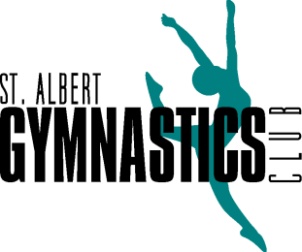

Full-Time Competitive Head Coach - St. Albert Gymnastics Club

The St. Albert Gymnastics Club is a not-for-profit, community based organization that provides programs in Artistic Gymnastics in a safe and positive environment to encourage learning and development. We use the fun, fitness and fundamentals model of gymnastics to help our athletes develop and reach their optimal potential.

We are looking for a Head Coach who is energetic, motivated, and organized, with a strong technical knowledge of concepts, practices and procedures within Women's Competitive Gymnastics. The Head Coach will develop, plan and coordinate competitive schedules and programs. Strong communication skills will be utilized with parents, Board members, other coaches and the athletes. We strive for a positive and focused training environment.
Hours of work:
This position involves an average of 37.5 hours per week, with at least 75% of the coach’s time spent actively coaching competitive gymnasts, and variety of day/evenings/morning and weekends. The remainder of time is for administration of the women’s competitive program. This is a salaried position with paid vacation.
Qualifications:
* NCCP Level 3 (minimum) in Women’s Gymnastics
* Respect in Sport Certification
* Making Ethical Decisions
* Level 2 trampoline trained
* First Aid & CPR
* Up-to-date Criminal Record & Vulnerable Sector Check
* Ability and experience in managing a competitive program
* Minimum 5 years coaching experience including programming for and working with children in a physical environment, and proficiency in women’s artistic coaching skills
* Excellent communication and leadership skills
* Prior experience as a Head Coach would be an asset but is not required
Roles And Responsibilities (not all inclusive):
* Coach JO 1-9 and Aspire athletes
* Set up and manage the competitive training program, ideally with an ability to work within current parameters
* Plan, develop and implement training and practice sessions for competitive gymnasts at all levels, as well as being able to mentor/support other coaches and help set/review policy for coaching operations
* Maintain regular communication with the competitive parents and competitive director, accomplished partially by dedicated and scheduled office hours
* Manage competitive coaches, including conducting annual performance evaluations
* Act as a technical director at our host meet
* Attend and travel for meets and clinics
* Formulate competitive strategies, develop plans and direct athletes during competitions
* Nurture and develop athletes’ potential skills and abilities
Compensation:
* Compensation and benefits are based on the candidate’s qualifications and experience
* Additional training can be provided
* Start date is negotiable
HOW TO APPLY
To apply for this position, please submit your resume and cover letter to president@stalbertgymnastics.com.

Contact Name
Jennifer Stickney-Lee

Club Name
St. Albert Gymnastics Club

Contact email
president@stalbertgymnastics.com

