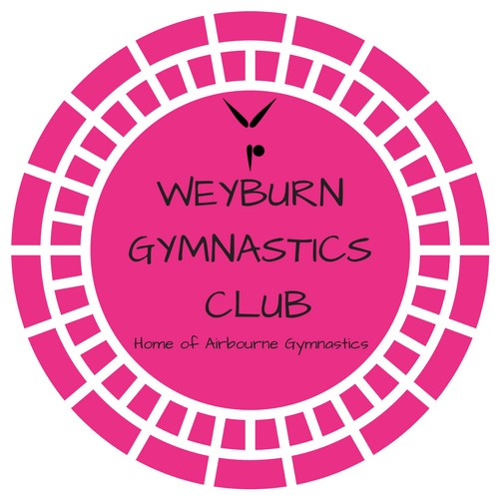
WAG Competitive Coach – Weyburn Gymnastics Club

The Weyburn Gymnastics Club (WGC) is seeking a Women’s competitive gymnastics coach for the 2019/20 season. WGC is a not-for-profit, community based organization that provides Recreational & Competitive Artistic Gymnastic programs. Our focus is to provide athletes with high quality, positive coaching to allow them to develop to their full potential.
We are looking for a Competitive Coach who is positive, energetic, motivated and organized, with a strong technical background of the JO program. The Competitive Coach will, in coordination with the Board of Directors, develop, plan and coordinate competitive schedules and programs. Strong communiciation skills are required and will be utilized when communicating with parents, athletes, Board members and other coaches. Maintaining a positive, respectful and focused environment is critical.
This position is currently part-time, however there may be an opportunity to add additional responsibilities/training groups to increase those hours depending on the candidate. The position requires flexible hours, evenings and weekend work.

Qualifications
The ideal candidate will have the following qualifications:
- NCCP Level 2 certified Women’s Gymnastics
- NCCP Level 2 Trampoline trained candidate
- Fluent English
- Valid Criminal record check, including Vulnerable Population check
- Valid Driver’s License
- Valid First Aid and CPR training

Please apply in confidence by May 31, 2019 to WGC Board of Directors – weyburngymclub@gmail.com
We thank all applicants for their interest, only those receiving an interview will be contacted.

