Womens Program Director
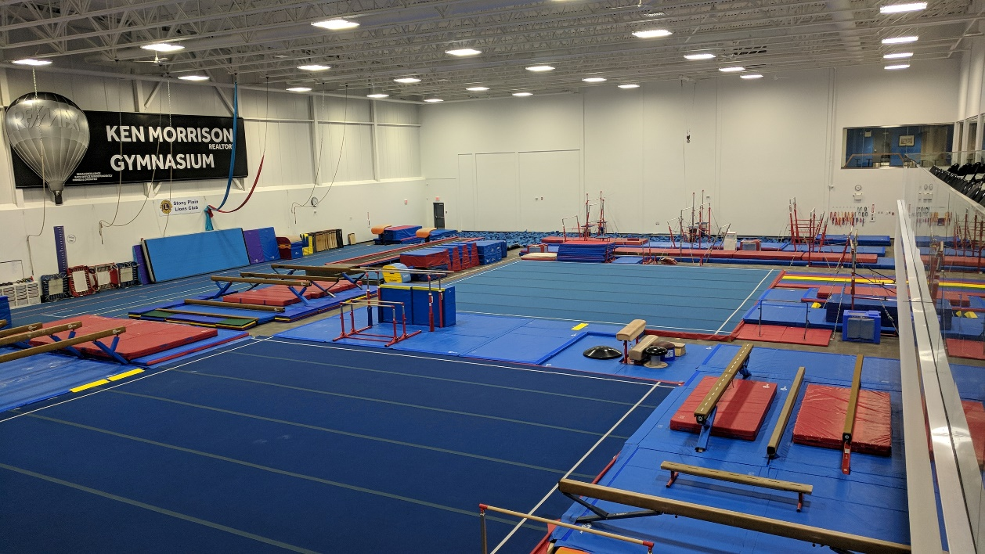
Join our team at Spruce Grove Aerials Gymnastics with just over 17,000 square feet of gymnastics space! A state-of-the-art facility located in beautiful Spruce Grove, just 10 minutes west of Edmonton, Alberta.
Spruce Grove Aerials is a not-for-profit organization community orientated gymnastics club that inspires enthusiasm for and lifelong involvement in gymnastics. The successful candidate must be an energetic team leader with proven communication skills and strong technical knowledge of the JO program. You will be responsible for overseeing the developmental and competitive program and work within Spruce Grove Aerials aligned vision for the program.
Requirements:
- NCCP Level 3 Certified
- Level 2 Trampoline
- Making Ethical Decisions/Respect in Sport/First Aid
- Current Vulnerable Sector Check
- Criminal Record Check
- Minimum 5 years coaching experience
- Demonstrated track record in the areas of program/coach development, communication and leadership
- Ability to work flexible hours including evenings/weekends
Responsibilities:
- Coach WAG athletes
- Ensure proper skill development and progression for both athletes and coaches
- Plan, develop and implement training plans
- Analyze and evaluate athlete performance and modify training program accordingly
- Communicate and work as a team with other directors and administration
- Communicate effectively with competitive parents and complete all administration work through regular office hours
- Participate and attend competitions, clinics and training sessions
Compensation:
This full-time position (37.5 – 40 hours per week) is a combination of coaching and administration duties, (minimum 30 hrs/coaching) and offers competitive compensation based on qualifications and experience. Position start date is May/June 2019. This is a salaried position with paid vacation.
How to Apply:
Please submit, in confidence, a cover letter and resume, with expected salary to lindsayk@aerialsgymclub.ca
Contact Name:
Lindsay Kiezik
Club Name:
Spruce Grove Aerials Gymnastics Club
Contact email:
lindsayk@aerialsgymclub.ca
Contact Phone:
780-962-5350

