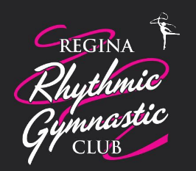
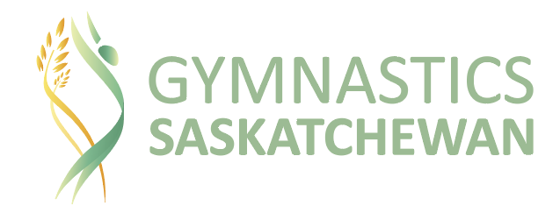

24th Annual Challenge Cup

Saturday May 2, 2020

Bulletin #1

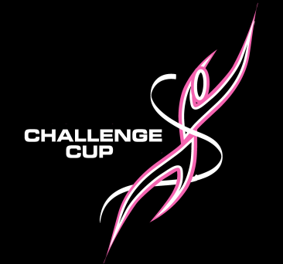

Challenge Cup 2020 – 24th Edition
DATE: Saturday, May 2nd, 2020
LOCATION: Campus Regina Public, Regina, Saskatchewan (1069 14th Ave East)
Tentative Schedule times subject to change:
Challenge Cup Group Practices 11:00 am – 2:00 pm
(club times will be provided in final bulletin)
Pre-adjudication meeting for adjudicators only 1:30 pm – 2:00 pm
Challenge Cup Adjudication – Closed to spectators 2:00 pm – 4:00 pm
Coaches & Adjudicators' meeting with light supper 4:00 pm - 5:00 pm
Open Gym for Practices 4:00 pm – 6:00 pm
GALA Show with Award Presentations 6:00 pm - 8:00 pm

Registration fees

$70 per group

Registration Procedure

Please find the registration workbook attached. Please fill out and email to: challengecup@hotmail.com

Please make cheques out to GymSask. Mail to 300-1734 Elphinstone Street, Regina SK, S4T 1K1.

Payment and registration are due by April 1, 2019.

A full Registration Package with the Script format and directions will be sent out in April with Bulletin #2. The script will outline the skills in the routine and the order they will appear in each routine for adjudication. A full list of skills is attached as well. Scripts will be due by April 30th please email to challengecup@hotmail.com.
Music will also be due by April 30th emailed to challengecup@hotmail.com. Coaches will need to bring a backup copy with them as well.

For more information please email: challengecup@hotmail.com

Regina Rhythmic Gymnastic Club
P.O. Box 32143
Regina Sk.
S4N 7L2

2019 CHALLENGE CUP RULES AND REQUIREMENTS
GENERAL ELIGIBILITY AND RULES

Challenge Cup is open to all gymnasts registered with Gymnastics Saskatchewan. It may be opened up to any other Provincial federation upon approval of Gymnastics Saskatchewan.

There are 3 categories at a Challenge Cup event. Groups with only one athlete above the training limit may register in the category of the majority as seen fit by the coach.
1. Performance – involves only those gymnasts who train 4 and less hours per week
2. Competitive – involves only those gymnasts who train 5 hours or more per week
3. Mature – involves men and women who are over 20 years old and train under 2 hour a week and may be coming out of retirement

There are 4 age groups per category. Age groups are determined by the age of the gymnasts in the group the day of the event. Groups with only one athlete above the age limit may register in the age category of the majority as seen fit by the coach.
Categories are:
• Age under 12 years old
• Age 12 to 14 years old
• Age 15 to 17 years old
• Age 18 years and older

Groups must have 6 to 11 gymnasts to be eligible for the awards. Groups not meeting the criteria may perform in the Challenge Cup and be evaluated but cannot be declared ‘’winner”. Exception: the age group 15 to 17 and 18 & older category that may present groups of 5 and still be eligible for awards. All groups may perform in the evening Gala regardless of size and may perform routines of their choice.

Groups can only perform in one category. Groups cannot perform with a winning routine from previous years.

Choreography must be original. Where technical elements may be taken from other choreographers for rhythmics, dance, cheerleading, etc., the combinations and full routine must not be.

Challenge Cup is not for beginners, gymnasts should have a minimum of 4 years of experience in all age categories except the under 12 category which should have 2 years of experience (including the current season). Exemptions may be requested to the host club.

Gymnasts may only perform with one group/team to be eligible for Challenge Cup awards. Coaches may choose to allow an athlete to perform on two teams but will need to declare which team is eligible.

Group registration fees are $70 each with a licensing fee of $20 per group. No individual registrations will be allowed.

Coaches must be Certified Gymnastics Foundations (or NCCP Level 1) and complete the Respect In Sport and Making Ethical Decisions programs in order to coach at Challenge Cup.

Routines must be a maximum of 2 minutes and 30 seconds for all age categories and routines.
Music is to be submitted electronically prior to the event. Music must be properly cut to fit the routine, including properly timed to match the ending.

APPARATUS REQUIREMENTS
• All groups can perform one free and one apparatus routine, for a total of maximum two routines per group. Groups may choose to participate in one routine only.
• Routines may include long skirts for the 15 to 17 and 18 and older age categories only (for free routine only).
• Free routine for all age group may include short extension of the costume such as a “sleeve flag”.
• A single prop maybe used to enhance the free routine but will not count towards adjudication.

TECHNICAL REQUIREMENTS
Each routine must display the following requirement by each gymnast in the group.
Coaches must declare what elements the group will be performing, and the order in which they appear.
Coaches will be required to complete the script form for each group and each routine to be submitted with their registration. Changes will be accepted no later than 48 hours prior to the scheduled start of the event.
• 4 formations
• 8 count dance series
• 2 exchanges (executed by all members of the group, apparatus routine only)
• 1 balance (visibly held for “2” seconds on flat foot)
• 1 pivot (360 degrees on 1 leg)
• 1 jump/leap
• 1 body wave movement
• 1 group collaboration
• 2 option body skills

• Skills must be performed at the same time by all gymnasts, or in immediate succession (cannon).
• Age appropriate apparatus handling should be a major part of all apparatus routines and will be evaluated by the technical panel.
• For all of the age categories originality will be part of the technical adjudication as well as the artistic adjudication.

2 option body skills adjudicated are chosen from a balance, pivot, jump/leap or wave movement. It is suggested that declared elements be selected from the Body Skills list provided to registered participants but are not required to be.

Under 12 age category:
• May select from Beginner & Intermediate Skills
• Majority from Beginner Skills

12 to 14 age category:
• May select from Beginner & Intermediate Skills

15 to 17 age category:
• May select from Beginner, Intermediate & Advanced Skills
• Majority from Intermediate & Advanced Skills

18+ age category:
• May select from Intermediate & Advanced Skills
• Majority from Advanced Skills

ADJUDICATION
Adjudicators will be made up of both rhythmic and non-rhythmic backgrounds (i.e. 2 rhythmic judges and a dance adjudicator).
There will be two panels of three adjudicators.

The following components will be evaluated by the artistic panel of adjudicators:
• Team unity
• Choreography (theme & composition)
• Originality
• Music appropriateness for age level and routine
• Aesthetic maturity

The following components will be evaluated by the technical panel of adjudicators:
• Technical merit (skill components – body & apparatus elements)
• Execution

CLARIFICATIONS
• First 2 exchanges (tosses) in routine will be adjudicated
• Other exchanges may count as collaborations
• Balances must not be on knee
• Collaboration and exchanges follow FIG regulations
• All athletes must perform technical skills in order to receive credit for the skills
• Balances on toes will be awarded extra if executed properly
• No knee drops allowed
• Apparatus handling during skill will count towards a higher execution of apparatus handling marks
• Dropped exchanges will count at a lower execution mark
• Collaborations may be in sub-groups if performed at the same time in routine

COACHES MEETING
A coaches meeting will be scheduled to take place during Challenge Cup. The agenda will include recommendations for technical regulation modifications for the next Challenge Cup.

GALA PERFORMANCE
A Gala Performance will be held in the evening for Challenge Cup. Teams may perform up to two routines, depending on the total number of routines. Groups are requested to perform at least one different routine from any routines presented earlier in the day at the Challenge Cup adjudication.

NEW for Challenge Cup 2020 – Workshop with Marta Kroupa

We are excited to announce that we are offering a workshop day on Sunday, May 3rd following Challenge Cup with an opportunity to work with Marta Kroupa, the creator and founder of Challenge Cup. This is an excellent opportunity to get to work closely with Marta for hands on feedback on your routines from Challenge Cup. Get feedback that will help you plan for next season and improve your routines.

- Sessions will be broken down into age categories for 2 hours each.
- Number of teams per session will depend on number of teams registered.
- Location and times to be finalized for April Bulletin.

Registration fees

$30 per group

Registration Procedure

Please find the registration workbook attached. Please fill out and email to: challengecup@hotmail.com

Please make cheques out to GymSask. Mail to 300-1734 Elphinstone Street, Regina SK, S4T 1K1.

Payment and registration are due by April 1, 2019.

