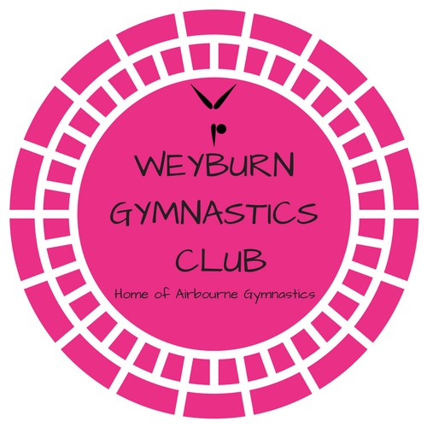
WAG Competitive Coach JO 5+
Weyburn Gymnastics Club

The Weyburn Gymnastics Club (WGC) is seeking a Women’s competitive gymnastics coach for our JO 5+ group for the 2019/20 season. WGC is a not-for-profit, community based organization that provides Recreational & Competitive Artistic Gymnastic programs. Our focus is to provide athletes with high quality, positive coaching to allow them to develop to their full potential.
We are looking for a coach who is positive, energetic, motivated and organized, with a strong technical background in the JO program. Strong communication skills are required and will be utilized when communicating with parents, athletes, Board members and other coaches. Maintaining a positive, respectful and focused environment is critical.
The position is part time, up to 13 hrs per week for this group. There is an opportunity for this position to be less than the 13 hrs with a WGC coach filling in to execute planned training. This position is currently part-time, however there may be an opportunity to add additional responsibilities/training groups to increase those hours if the successful candidate is looking for additional hours.

Qualifications
The ideal candidate will have the following qualifications:
- Competition I Certified
- T&T Level II trained
- Valid Criminal record check, including Vulnerable Population check
- Valid Driver’s License
- Valid First Aid and CPR training
Wages are negotiable and mileage will be compensated
Please apply in confidence as soon as possible to WGC Board of Directors – weyburngymclub@gmail.com
We thank all applicants for their interest, only those receiving an interview will be contacted.

