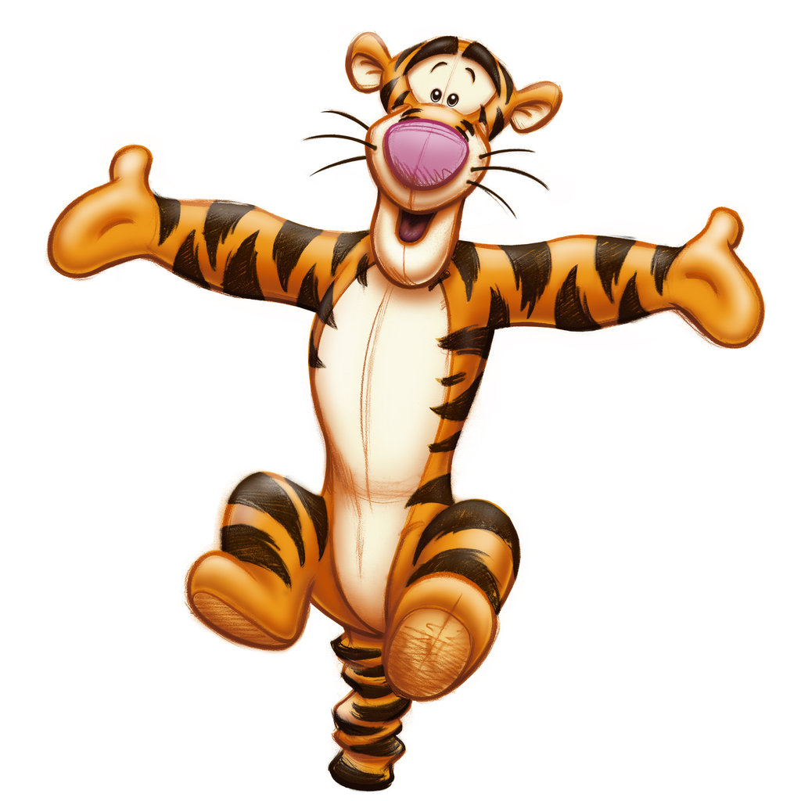

SPRING INTO SPRING Invitational 2020
Date: April 17 – 19, 2020
Location: Gymtastiks of Moose Jaw
Hillcrest Sports Centre
1599 Main Street N. Moose Jaw, SK. S6J 1L5

Entry Fee: $125.00 J.O. 3-7
$100.00 J.O. 1 & 2
$125.00 Xcel
$50.00 for Recreational

Payment can be made by one cheque, made payable to Gymtastiks of Moose Jaw. Please send a hard copy of your registration with all waivers. Each athlete registered by the deadline will receive a T Shirt. Late registrations will not be guaranteed a T Shirt. Please submit registrations via e-mail complete with T shirt sizes for athletes and coaches. Please submit Recreational Routines as soon as possible.
Registrations are due Wednesday, March 4, 2020. Registrations received after March 4th will be subject to a $25.00 late fee per athlete. Space is limited so register early. Spots will be awarded on a first come first serve basis until we are full.
Refunds for medical reasons will be given, with a doctor’s note, on or before April 10, 2020. Gymnasts will be registered when both forms and payment have been received.

Deadline: Deadline is March 4, 2020. Please do not send as PDF.

Awards: J.O. 1-7 & XCEL - As per Gymnastics Saskatchewan Policy.
Recreational – participation medal.

Inquiries: Barb Jesse
Phone: 306-692-2303
E-Mail: office@gymtastiks.com

Music: Compulsory music will be supplied. Please bring optional music on CD.

ACCESS TO THE GYM is from Main Street turning East onto Thatcher only!

HOTEL DEALS – make sure to mention that you are a participant at the Moose Jaw Gymtastiks Competition.
Super 8 by Wyndham: (306) 692-8888; super8moosejaw@hotmail.com
Located at 1706 Main Street North
Comfort Inn: (306) 692-2100; comfortinn@sasktel.net
Located at 155 Thatcher Dr. W.
Grant Hall: (306) 691-2113; ellen@granthall.ca
Located at 401 Main Street North
Temple Gardens Hotel & Spa: (306) 694-5055; generalmanager@templegardens.sk.ca
Located at 24 Fairford St. E.
Quality Inn & Suites: (306) 972-7829; arauscher@encorehotels.ca
Located at 323 Diefenbaker Drive

GYMTASTIKS OF MOOSE JAW
SPRING INTO SPRING INVITATIONAL
April 17 – 19, 2020
TENTATIVE SCHEDULE
SATURDAY APRIL 18, 2020
SESSION 1 – 8:00-10:30 J.O. 3
SESSION 2 – 10:30-1:00 J.O. 3
SESSION 3 –1:30-5:00 J.O. 4-7 & Xcel Gold, Platinum, Diamond
SESSION 4 –5:00-8:00 J.O. 2 & Xcel Silver & Bronze
SUNDAY APRIL 19, 2020
SESSION 5 – 8:00-11:00 J.O. 2
SESSION 6 – 11:00-2:30 J.O. 1
SESSION 7 –2:30-6:00 J.O. 1 & RECREATIONAL
**** J.O. 1 & 2 SESSIONS – PLACEMENT OF CLUBS WILL BE DETERMINED AFTER REGISTRATION DEADLINE.
We reserve the right to utilize one Session on Friday evening if needed.

WAIVER

Name of Athlete: _________________________________AGE: ______________
PLEASE PRINT CLEARLY

GYMTASTIKS OF MOOSE JAW
SPRING INTO SPRING Invitational
April 17 – 19, 2020

In consideration of your acceptance of my entry I, intending to be legally bound do hereby, for myself, my heirs, executors and administrators waive and release and forever discharge any and all rights and claims for damage which I may have or may hereafter accrue to me against the Gymnastics Saskatchewan Association, the organizers or their respective officers, agents, representatives and/or assigns for any and all damages which may be sustained and suffered by me in connection with my association with or entry in the above athletic meet or which may arise out of my traveling to or participating in and returning from said athletic meet.

Submission of your registration to the Gymtastiks SPRING INTO SPRING Invitational constitutes your consent to collect, use, disclose and retain your personal information as is reasonable for Gymnastics Saskatchewan and the Gymtastiks Club for the following purposes:
Name, event results, programs, web site results and photo posting.

Athlete’s Signature
(If 18 years of age or over)

Parent/Guardian Date

T shirt size: _________________
GYMTASTIKS OF MOOSE JAW
SPRING INTO SPRING Invitational
April 17 – 19, 2020
RECREATIONAL ROUTINE SHEET

Please list skills that will be performed; fill out a sheet for each athlete attending.
Please ensure skills are at the athlete’s level.

ATHLETE NAME: ____________________________________________

VAULT – CHOOSE FROM (Please indicate which one):
- Squat on to 60 cm Box
- Handstand fall to back on crash mat
- Handspring to back on 110 cm mats, with Mini Tramp

BARS – 6 skills
__________________________________________________________________________________________________________________________________________________________________________________________________________________________________________________________________________________________________________________________________________________________________________________________________________________________________________________________________________________________________________

BEAM – 6 skills (mount, 1 turn, 2 leaps or jumps, 1 scale or acro, dismount)
__________________________________________________________________________________________________________________________________________________________________________________________________________________________________________________________________________________________________________________________________________________________________________________________________________________________________________________________________________________________________________

Floor – 6 skills (3 acro skills, 1 turn, 2 leaps or jumps)
__________________________________________________________________________________________________________________________________________________________________________________________________________________________________________________________________________________________________________________________________________________________________________________________________________________________________________________________________________________________________________

