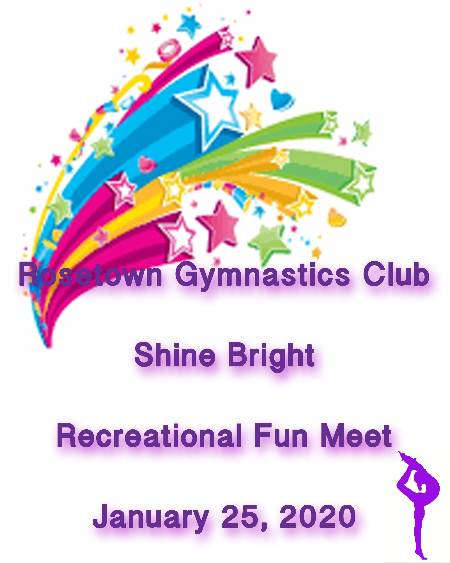

ROSETOWN GYMNASTICS CLUB
SHINE BRIGHT
RECREATIONAL FUN MEET
January 25, 2020

LOCATION: Rosetown & District Civic Center
Highway #4 (north end of town)

MAILING ADDRESS: Box 1301
Rosetown, Saskatchewan
S0L 2V0

AGE: Recreational – age 5 and over

AWARDS: All gymnasts will receive a medal and a treat bag

ENTRY FEE: $60.00 per gymnast

REFUND POLICY: Refund with Dr. certificate only, no refunds after Jan. 11th.
All refunds subject to $25.00 processing fee

SCHEDULE: Times are tentative depending on number of gymnasts
attending. (Max. 60 athletes per session)
Ages 5 - 8 Ages 9 and over
Warm-up 9:30 1:30
Competition 10:00 2.00
Awards 1:00 5:00

REGISTRATION
DEADLINE: December 13, 2019
Late fee of $25.00 per gymnast will apply for registrations received after the deadline

ROUTINES: Participants will be judged on skills listed on routine sheet, please fill out and return prior to meet.

BOYS: Will replace beam with a parallel bar routine

SPOTTING: Will be allowed. Please ensure that gymnasts only include skills they can do.

EQUIPMENT: Floor – without springs

CONCESSION: Will be available, soup, snacks, beverages
QUESTIONS: Fern Dyer (306)882-4022 or rosetown.gymnastics@sasktel.net

ROSETOWN GYMNASTICS CLUB
SHINE BRIGHT
RECREATIONAL FUN MEET
January 25, 2020

Recreational Registration Form

Club Name________________________________e-mail_______________
Club Contact_______________________________ phone______________
Gymnast  Name | Birth  Date | Age

Coaches attending
__________________________ ___________________________
__________________________ ___________________________

Fees: ________ gymnasts x $60.00 = _______________________

Late Fee(after Dec 13th) ____________gymnasts X $25.00 = ____________

Note: Make cheque payable to: Rosetown Gymnastics Club (one cheque per
club please)

Routine Sheet
Please list skills that will be performed; fill out a sheet for each athlete attending
Please ensure skills are at athletes level

Athletes Name ______________________________

VAULT
Choice of squat on to 60cm box
Or
Handstand fall to back on crash mat
Or
Handspring to back on 110cm mats, with mini tramp

BARS – 6 skills
BEAM – 6 skills (mount, 1 turn, 2 leaps or jumps, 1 scale or acro, dismount)
FLOOR – 6 skills (3 acros, 1 turn and 2 leaps or jumps)
PARALLEL BARS – 6 skills

ROSETOWN GYMNASTICS CLUB
SHINE BRIGHT
RECREATIONAL FUN MEET
January 25, 2020

ATHLETE’S WAIVER FORM

Name of Athlete: ___________________________________________________

In consideration of your acceptance of my entry, I, intending to be legally bound do hereby, for myself, my heirs, executors, and administrators waive and release and forever discharge any and all rights and claims for damages which I may have or may hereafter accrue to me against the Rosetown Gymnastics Club, the organizers, or their respective officers, agents, representatives, and or assigns for any and all damages which may be sustained and suffered by me in connection with my association with or entry in the above athletic meet or which may arise out of my traveling to or participating in and returning from said athletic meet.

__________________
Athlete’s signature
(If 18 years of age or over)

___________________ ____________________
Parent or Guardian Date

ACCOMODATIONS

Country Rose Inn
Hwy 7
882-3093

Travelodge
Hwy 7
882-4200

