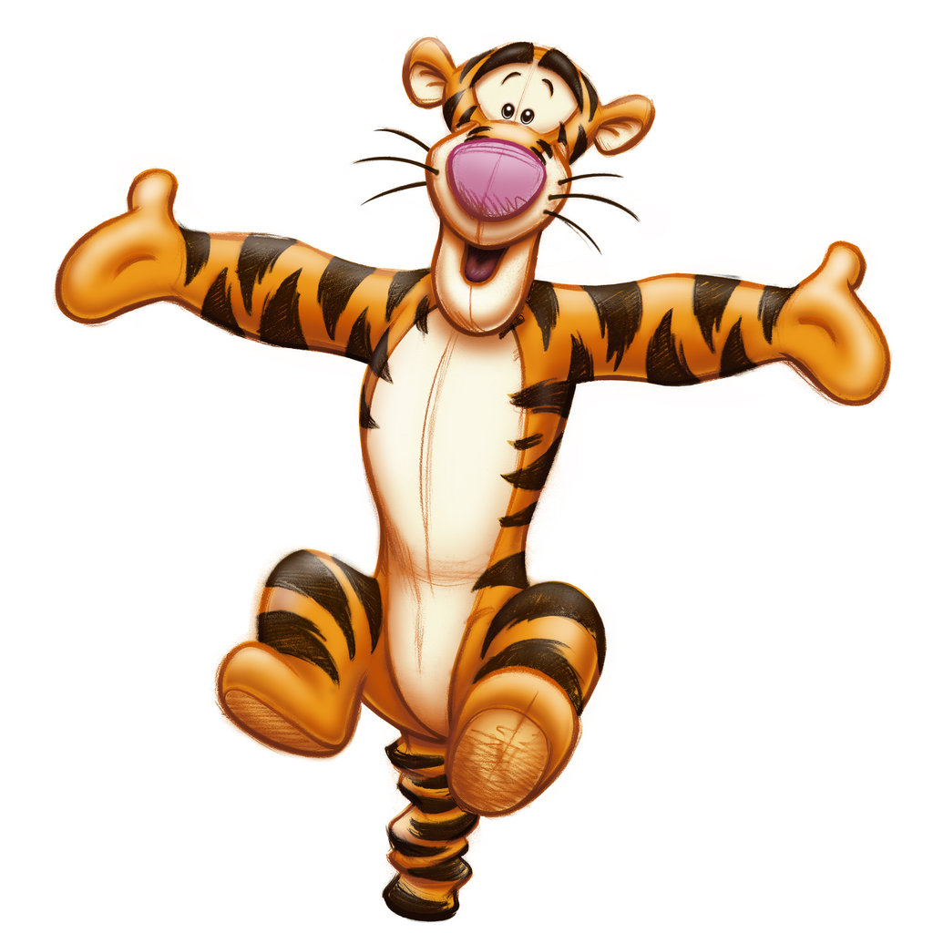
GYMTASTIKS OF MOOSE JAW
SPRING HAS SPRUNG INVITATIONAL
APRIL 17-19, 2020
FINAL SCHEDULE: revised March 7
FRIDAY APRIL 17, 2020
Session 1 – 5:00-8:30 JO 4 (53)
SATURDAY APRIL 18, 2020
SESSION 2 – 8:00-11:45 JO 5-7 (38)
SESSION 3 – 11:45-2:45 JO 3 2009, 2010, 2011 (57)
SESSION 4 –2:45-5:45 JO 3 2008 & BEFORE (23), Xcel (23)
SESSION 5 –5:45-8:45 JO 2 (43) YORKTON, TAISO, CARNDUFF, GELICO, ESTERHAZY,
BATTLEFORD, ROSETOWN, WAINWRIGHT, PRINCE ALBERT
SUNDAY APRIL 19, 2020
SESSION 6 – 8:00-11:00 JO 1 (10) GELICO &, JO 2 (36) ESTEVAN, QUEEN CITY, ZERO GRAVITY,
ROSS GYM & FIT, GYMTASTIKS
SESSION 6 – 11:15-2:15 J.O. 1 (43) ESTEVAN, CARNDUFF, ROSS GYM & FIT, YORKTON, BATTLEFORD, PRINCE ALBERT, ROSETOWN, ESTERHAZY
SESSION 7 –2:30-5:00 J.O. 1 (25) WEYBURN, QUEEN CITY, GYMTASTIKS & RECREATIONAL (22)

